Forgot Windows Vista Password? Ways to Find Windows Vista Password

Article Source:
http://recoverlostpassword.com/article/forgot-windows-vista-password.html
Question: I forgot my Windows Vista password and now can’t login to my Windows Vista anymore. How can I find my Windows Vista password?
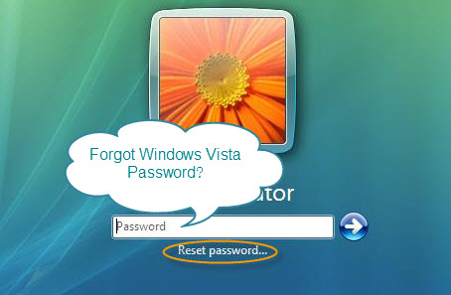

Answer: Forgot your Windows Vista password? Do not fret- it may happen to each of us. For security, we're supposed to make a strong password that is difficult to detect by other peoples, but sometimes we are so roughly that we forget vista password and have no idea how to find it. Here I’ll recommend your several ways to find your Vista password when you forgot Windows Vista password .
Option 1: Windows Vista Password Reset Disk
If you are smart have created a Windows Vista password reset disk at some point in the past, now is the time to use it to reset the forgotten Windows Vista password! If you have changed your Windows Vista password after creating it, the disk still work to reset your forgotten vista password. Follow the instructions below to reset Windows Vista password.
Step 1: Click “Reset Password” link below the login box. The Password Reset Wizard starts. The Password Reset Wizard allows you to create a new password for your user account. Then click Next.
Note: you have to insert your Vista password reset disk into your drive firstly, or you’ll get an error message:
Step 2: Pick the right disk if you have more than one.
Step 3: Type in a new password and a hint for the password. Click Next. To close the wizard, click Finish.
Option 2: Free Windows Password Recovery Tool
If you are looking for some free Windows password recovery tool to recover your forgotten vista password, Ophcrack, Offline NT Password & Registry Editor are your best choice. But there is a condition that you should master computer technical so well because of their complexity on operation. So if you are a compute green hand, I recommend you try another way or other Windows password recovery tools.
Options 3: Commercial Windows Password Recovery Program
If by far you haven’t found your forgotten Vista password, then it's time to get serious. Search on Google to find Forgotten Windows Vista Password recovery solution. When you are confused by so many commercial windows password recovery software, I recommend you use Windows Password Recovery 6.0. With it, you can get instant access to your forgotten Windows vista system by burning a bootable CD/DVD or USB flash drive. The biggest advantage of Windows Password Recovery 6.0 is its 100% recovery rate and its easy-to-user feature, even a computer novice can easily reset forgotten Windows Vista password within 5 minutes through this guides:
Step 1: Download Windows Password Recovery 6.0 and install it.
Step 2: Burn Windows Password Recovery 6.0 to CD/DVD or USB flash drive.
Step 3: Boot the locked PC form CD/DVD or USB.
Step 4: Reset Forgotten Windows Vista password to be blank.
BTW，Except Forgetting Windows Vista password, even if you forget Windows 7/Vista/XP/2000 and Windows Server 2008/2003 password, you can also reset the forgotten password by Windows Password Recovery 6.0.
Option 4: Still Can't Find Your Windows Vista Password
If you still can't find your forgotten Windows Vista password, you will need to do a "clean install" of Windows Vista. This is a destructive step but if you forgot your Vista password and can't find the password in any other way, a clean install is guaranteed to help you get access to your PC again.

More Forgotten Vista Password Related Articles:
- Create a Windows Vista Password Reset Disk.

Related Articles:
- Forgot Windows XP Password?
- Forgot Windows 7 Password?

